Technology: NOAA Ice Moorings Technology POC: Noah Lawrence-Slavas

This information is being requested to assist the R&D Center and the HEALY with mission planning and resource management to ensure this cruise will be a success for everyone involved. Inputs should focus on mission requirements and ship resources that will be needed to facilitate your mission execution. Please provide the information at a level that is adequate for someone with no prior knowledge of your technology. Please review information about the HEALY on icefloe.net before filling out (http://icefloe.net/uscg-science-support-overview)

Short Description of Technology

“Pop-up” Buoy:
A satellite tag attached to a float which is designed to collect data on under-ice conditions. The device will be deployed under the ice and rest on the sea floor. At a predetermined time, it will release from the bottom, rise through the water column and collect data at the ice boundary under the surface. It will continue to collect data until free of the ice and will relay data to shore via satellite.

Objectives of Test/Operation

This is the first prototype of the “Pop-up” Buoy. The primary objectives are to
- Assess the survivability of buoys and satellite tags (Do they arrive at the surface after ice break-up?)
- Gather preliminary data on under-ice conditions
- Measure movement and orientation of buoys under the ice
- Assess data quality of satellite tags
For this operation, two “Pop-up” buoys will be deployed

Preferred Operating Environment

- The “Pop-up” buoys must be deployed in a location where ice is well-formed. Since they must reach the sea floor, the simplest method is to deploy them from the stern of the ship as it passes through an area of well-formed ice. The exact location is dependent on the ice-extent at the time of the cruise. However, the buoys will be deployed along the ship’s track, where bottom depth is ~40-50m.
- Since the “Pop-up” buoys are relatively small and will be deployed in an ice-covered area, environmental conditions will only be a limiting factor if extreme conditions make the deployment a safety risk for personnel or make the equipment difficult to control while placing it in the water. (See section on Launch and Recovery for more details).
- Deploying the “Pop-up” buoys at night is undesirable as this will be the first prototype and first ship-board deployment of the technology. Nonetheless, the launch procedure should be simple and the equipment is not cumbersome or complicated. They may be deployed at night if deemed necessary.

Equipment Information

The “Pop-up” buoys are self-contained autonomous instruments which have no unique power or storage requirements. They consist of a buoy with a counter-weight, a small chain/cord assembly, and an anchor. They may be disassembled for storage and reassembled before deployment.
The buoy with counterweight should be stored indoors or covered to limit exposure to environmental conditions and seawater.
The only ‘hazardous’ material in the buoys is a single D-cell lithium battery encased in the satellite tag. It is completely encased in epoxy and poses no threat of exposure to water unless catastrophically damaged.

Page 2
Pictures of Technology

The photo below shows the major components of the system. From left to right:
- 50 lb anchor
- Small corrodible link
- 10 lb weight
- Small corrodible link
- Buoy with counterweight (~50 lb)
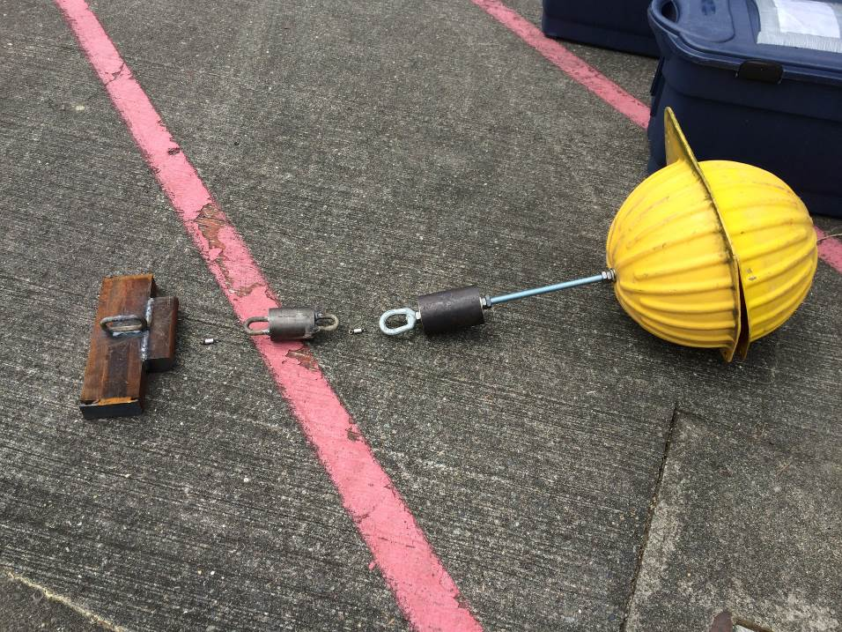

The entire assembly weighs ~120 lbs. It will be strung together with cord and approximately 7 ft in length.

Lab Space/Mission Execution Area

As indicated above, the “Pop-up” buoys should be deployed from the stern of the ship in an ice-covered area. The team will need a small staging area to assemble the buoys and adequate space on deck to safely deploy them. There are no other special requirements for mission execution or lab space.

Launch and Recovery

The “Pop-up” buoys should be deployed from the stern of the ship in an ice-covered area at 0-1 knots. The equipment should be suspended over the side (with use of a crane if necessary), lowered into the water, and released. It may require up to 5 personnel, including a crane operator, to carefully maneuver the equipment.
The equipment weighs ~120 lbs and is ~7 ft in length altogether. It will be fitted with a single pick point on the side of the yellow buoy for crane pickup. It may be deployed by hand if a crane is not necessary.
The units are connected with 2 very small corrodible links which are not rated for heavy loads. Extra precaution should be given during deployment to ensure the string of equipment is not placed under heavy loads or subjected to any shock loading. It should be lifted, maneuvered, and lowered into the water smoothly before releasing.
Actual launch procedures should take less than 10 minutes for each buoy. However, time required to select a location, stage equipment, slow the ship, and coordinate deck operations will likely take closer to an hour.
No other specialized equipment such as small boat or lifting straps is required.
The equipment is not intended to be recovered. In the extremely rare event that the buoys are deployed at the start of the cruise and the ship passes by them in an ice-free area near the end of the cruise, the buoys may be recovered. Doing so would involve hooking the buoys alongside the ship and hoisting them aboard by hand. The weight of the buoy assembly is 50 lbs.

Weather Contingencies

In the event that environmental conditions prohibit launch, the operations should be rescheduled for another time later in the cruise. As long as the primary constraints are met (ice-covered area, ~40-50m depth), the exact geographic location of the deployment is not critical. If it is not possible to launch at any point when the ship is in a suitable location, the equipment should not be deployed.

EMF Information

Each buoy has a satellite tag embedded in the equipment. Tags will only transmit data after the equipment has been deployed by the ship. They utilize a TWIC RF module (0.5W) to transmit data via the Argos satellite system. More info on the satellite tags can be obtained from University of St Andrews’ Sea Mammal Research Unit.

